Reducing your personal greenhouse gas emissions.

Janet Stephenson, Centre for Sustainability, University of Otago.
24 March 2019

Reducing greenhouse gas emissions is a shared responsibility. Action is needed at all scales – by global organisations, nations, councils, businesses, organisations, as well as by people in their personal lives. Without concerted action we will not achieve the emissions reductions needed to avoid devastating impacts on human life, other species, and the natural systems we depend on. The following 2 pages describes 10 ways in which you can help reduce emissions in your everyday life.

But to start, some background. The Intergovernmental Panel on Climate Change has made it clear that going beyond a 1.5 degrees C increase in average global temperature will have dire consequences. To limit warming to 1.5 degrees, the world needs to radically reduce greenhouse gas emissions by 2030, only 11 years away, and achieve zero net carbon by the second half of the century. Rapid changes to current systems of production and consumption are needed. The global temperature is already heading towards 1.5 degrees and many impacts of climate change are already well established.

In New Zealand, nearly half of our emissions come from burning fossil fuels (coal, diesel, petrol, natural gas, LPG, all of which produce carbon dioxide) and about half from farming (mainly methane and nitrous oxide), with small amounts from waste and industrial processes.

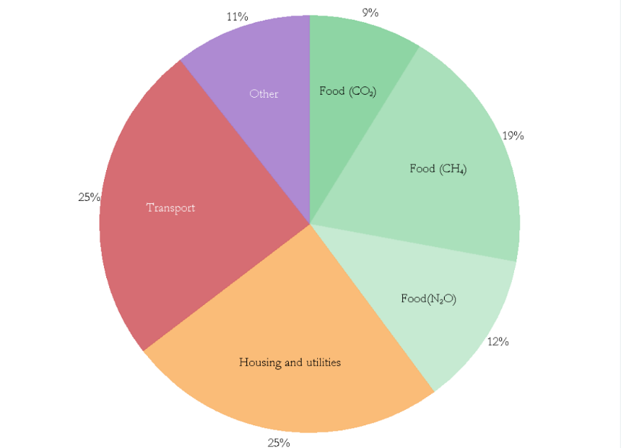
Individuals and families can do many things to reduce the greenhouse gas emissions associated with their everyday lives. These emissions come from direct use (e.g. driving a car which burns diesel) and indirectly (e.g. emissions involved in producing the food you eat).

Research by Motu (see diagram above) shows that around a quarter of the average family’s emissions come from their use of energy in the home, another quarter from the transport, and around 40% from food. Wealthier families tend to have higher emissions, particularly from flights.
10 ways to reduce your greenhouse gas emissions

1. Use your car less
- Walk and bike more often, and improve your fitness at the same time.
- Take advantage of shared mobility services such as bike, scooter and car schemes, as well as public transport.
- Carpool, share your car , your road trip or your commute.

2. Electrify your transport
- Are those hills a bit much? Maybe you should get an electric bike.
- Make your next car purchase an electric vehicle.

3. Limit your flying
- Fly less often than you did last year, and/or take a year off flying internationally.
- If you have to fly, offset your carbon emissions when you purchase your air tickets.
- If your airline doesn’t have an offset scheme or you don’t offset when you buy, you can still offset your emissions after you’ve flown, e.g. with this or this NZ scheme.

4. Avoid using fossil fuels for heating
- Choose the low-carbon heating option that’s best for your situation.
- Use wood rather than coal (e.g. in solid fuel burners, pellet fires).
- Heat pumps use electricity very efficiently compared to most other types of electric heater.

5. Keep in the warmth (and keep out the heat in summer)
- Insulate your home, and think about wall insulation as well as ceiling and under-floor insulation.
- Invest in double glazing.

6. Make your own
- Check if it makes sense for you to invest in solar panels (PV) or small-scale wind generation.

7. Adjust your food habits
- Become aware of the emissions involved in producing your food
- Eating less meat and milk is the single biggest way to reduce your emissions.
- Reduce your food waste.
- Compost your food and garden waste rather than send it to landfill.

8. Invest in the future
- Are you are involved in Kiwisaver or other superannuation scheme, or do you have other investments?
- Ask your fund manager about responsible investment options that don’t support the fossil fuel industry.
- In New Zealand, responsible investment has increased rapidly and now represents the vast majority of NZ investments.
- Globally, many major institutions are divesting their funds from the fossil fuel industry.

9. Work out your emissions footprint and commit to reducing it over time
- Knowing where most of your greenhouse gas emissions come from will help focus your efforts.
- There are many carbon calculators available online but make sure you choose ones developed for NZ conditions.
- Even simple tools can give a general idea.
- More tailored tools allow you to personalise your data, and can help you track your changing emissions over time. NZ tools are being improved, including to incorporate food-related emissions.

10. Make your voice heard
- Demand and support sustainable businesses, especially those that are zero carbon or commit to radically reducing their carbon footprint.
- Demand and support your council to commit to a low-carbon future, develop action plans and invest in solutions that help households, organisations and businesses to reduce their emissions.
- Demand and support government initiatives to get New Zealand to net zero greenhouse gas emissions by 2050.
- Support, acknowledge or engage with others locally or nationally working for a low-carbon future, including iwi, environmental groups, young adults, school students and coalitions for climate action.

Note: The hyperlinks show sources of more information, but don’t represent all that’s available. Look more widely and weigh up options before you choose. And think about what suits your needs, aspirations and income. Some options have quite a high up-front cost, but may pay for themselves in the longer term. Some options don’t cost anything but may involve some changes to your lifestyle.

